**The Issue**

In California, utilities, customer and consulting engineers and regulators need to exchange power system data to validate distributed energy resource plans, obtain permits, and verify compliance when integrating these resources in distribution systems. The data exchange process between the many different tools used can be cumbersome, slow and error prone. This raises a barrier to fast and effective resource planning and integration, which limits the growth of these resources and constrains how quickly California can decarbonize its electric power infrastructure.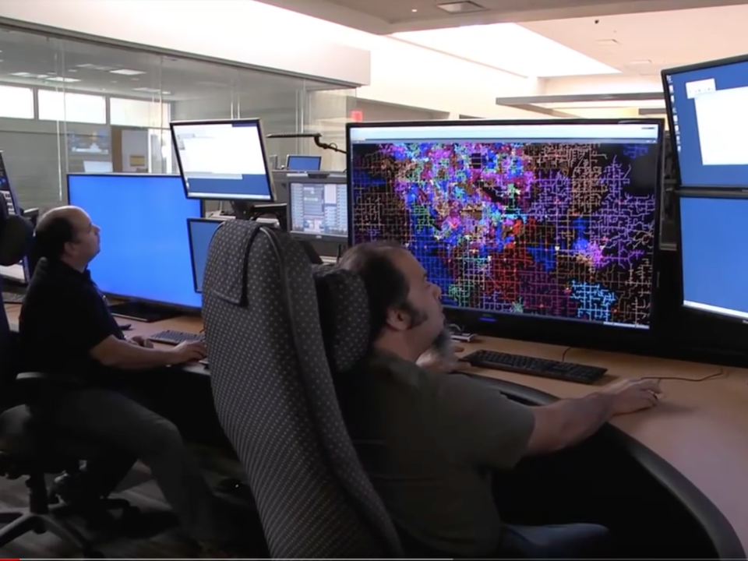

**Project Description**

OpenFIDO is a data interchange, synthesis and analysis platform that provides information exchange between widely used power system analysis and simulation tools such as CYME and GridLAB-D. OpenFIDO can transfer models and data between tools that are part of the suite of tools widely used by utilities, distributed energy resource (DER) engineers and regulators in California. OpenFIDO is designed for system planners, engineers, and analysts who need to quickly and reliably move data from one application to another as part of their regular activities. OpenFIDO also supports emerging user groups such as DER system integrators and aggregators that rely on diverse tools to manage the impact of DERs, as well as governments and agencies that use these models in identifying opportunities for clean energy deployments, addressing system resilience to extreme weather events, and mitigate the impact wildfires.

The long-term goals of OpenFIDO are to enable full interoperability between open-source software such as GridLAB-D and OpenDSS and various commercial power distribution system modeling tools such as CYME, Opal-RT, and RTDS. In addition, OpenFIDO enables easy development and adoption of new tools and analysis methodologies that depend on many diverse public and proprietary datasets for weather, demographic, system telemetry, tariff and market data, and other data collection programs run by utilities, regulators, and commercial entities.

The objectives of the OpenFIDO project are:

1. *Produce a widely usable and fully functional data platform and interoperability layer for various power systems tools*. Southern California Edison has successfully deployed OpenFIDO and conducted an broad evaluation with staff who support regulatory, planning and operations activities supported by tools based on GridLAB-D.
2. *Deliver a data exchange platform along with a set of data adapters* to convert data from power systems tools’ schema to a standardized, open-source format. Southern California Edison has successfully deployed OpenFIDO to convert Cyme models to GridLAB-D format for use in electrification and resilience analysis.
3. *Establish the foundation for long-term user and developer support*, including tools and services for data import, transformation, storage, access, and export. Several utilities nationwide have tested and/or are currently evaluating OpenFIDO for various use-cases, including load forecasting, resilience analysis, electrification, tariff design, and hosting capacity analysis.

**Benefits for California**

OpenFIDO provides multiple benefits to California’s electricity ratepayers by helping utilities work with customers and regulators to ensure DERs are integrated into electricity distribution systems planning processes more quickly, reliably, and cost-effectively. Customer-based generation, storage and demand response resources must be planned and deployed in coordination with utilities, and OpenFIDO provides many of the tools needed to facilitate the conditions wherein all parties can contribute and obtain the data they need to perform their respective system equity, reliability, and resilience analyses quickly and accurately.

In addition, OpenFIDO provides the environment within which the tools used in DER resource financing, planning and permitting processes can interoperate. As OpenFIDO usage grows, it will help utilities and other stakeholders more reliably and efficiently exchange system model data with analysts, regulators, and vendors. The reduction in labor intensity and cost of staff training will improve utility staff productivity, help expedite utility resource integration reviews, and simplify utility regulator compliance activities. All these work reductions will ultimately result in savings to ratepayers and increase the rate of beneficial electrification.

**Project Specifics**

Contractor: SLAC National Accelerator Laboratory, Menlo Park CA

Partners: GridWorks, Oakland CA (subcontractor)  
Pacific Northwest National Laboratory (subcontractor)  
National Grid, Hicksville NY (cost-sharing partner)

Amount: $1,000,000

Co-funding: $30,000 (cost-share)

Term: June 2018 to March 2023

Contact: David P. Chassin (dchassin@slac.stanford.edu)